**==========================KPI==============================================**

1. **Total Customer**

**Query :-**

select round(count(distinct customer_unique_id)/1000,2) Total_customer

from olist_customers_dataset;

**Screenshot :-**

**============================================================================**

**============================================================================**

1. **Total Seller**

**Query :-**

select count(distinct seller_id) Total_seller

from olist_sellers_dataset;

**Screenshot :-**

**============================================================================**

**==============================================**

1. **Total Sales**

**Query :-**

select round(sum(payment_value)/1000000,2) Total_sales

from olist_order_payments_dataset;

**Screenshot :-**

**============================================================================**

**============================================================================**

1. **Total Profit**

**Query :-**

select sum(pd.payment_value) Sum_payment_value,sum(od.price) Sum_price,

round((sum(pd.payment_value) - sum(od.price))/1000,2) as Total_profit

from olist_order_payments_dataset pd,olist_order_items_dataset od

where pd.order_id=od.order_id;

**Screenshot :-**

**============================================================================**

**============================================================================**

1. **Total Order :**

**Query :-**

select count(distinct order_id) Total_order

from olist_order_items_dataset;

**Screenshot :-**

**==============================VISUALS=======================================**

1. **Weekend Vs Weekday Payment :**

**Query :-**

select

case when dayofweek(STR_TO_DATE(OD.order_purchase_timestamp, '%Y-%m-%d')) in(1,7)

then 'Weekend' else 'Weekday' end as Day_Type ,

count(distinct od.order_id) As Total_orders,

round(sum(pd.payment_value)) AS Total_Payments,

round(avg(pd.payment_value)) AS Average_Payments

from olist_orders_dataset od

join olist_order_payments_dataset pd on pd.order_id=od.order_id

group by Day_Type;

**Screenshot :-**

**============================================================================**

**============================================================================**

1. **Number of Orders with review score and payment type.**

**Query :-**

select pd.payment_type,count(distinct rd.order_id) as count_of_order

from olist_order_payments_dataset pd,olist_order_reviews_dataset rd

where pd.order_id=rd.order_id

and rd.review_score=5

group by pd.payment_type;

**Screenshot :-**

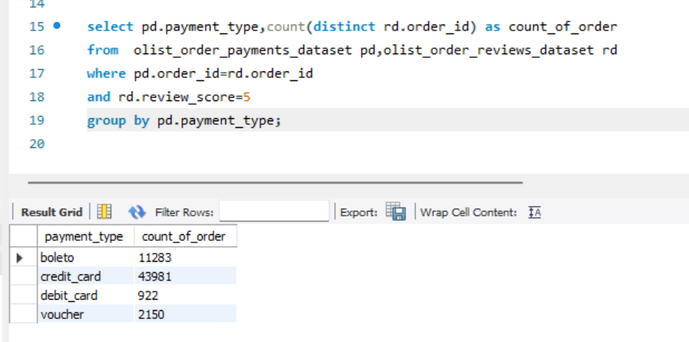

**============================================================================**

**============================================================================**

1. **Product Categorywise Total delivery Average**

**Query :-**

select

pd.product_category_name,

round(avg(DATEDIFF(OD.order_delivered_customer_date,OD.order_purchase_timestamp))) AS AVG_DELIVERY_TIME

from olist_orders_dataset od

join olist_order_items_dataset id on id.order_id=od.order_id

join olist_products_dataset pd on pd.product_id=id.product_id

WHERE pd.product_category_name='pet_shop'

and OD.order_delivered_customer_date is not null;

**Screenshot :-**

**============================================================================**

**============================================================================**

1. **Citywise Payment Average and Price Average**

**Query :-**

select cd.customer_city,round(avg(pd.payment_value)),round(avg(id.price))

from olist_orders_dataset od, olist_customers_dataset cd,

olist_order_payments_dataset pd, olist_order_items_dataset id

where od.customer_id=cd.customer_id

and pd.order_id=od.order_id

and id.order_id=od.order_id

group by cd.customer_city;

**Screenshot :-**

**============================================================================**

**============================================================================**

1. **Relation Between Shipping days.**

**Query :-**

SELECT

round(avg(DATEDIFF(OD.order_delivered_customer_date,OD.order_purchase_timestamp))) AS AVG_SHIPPING_DAYS,

review_score

from olist_orders_dataset od

join olist_order_reviews_dataset rd on rd.order_id=od.order_id

where OD.order_delivered_customer_date is not null

and od.order_purchase_timestamp is not null

GROUP BY review_score;

**Screenshot :-**

**============================================================================**

**============================================================================**

1. **Product Category wise Price**

**Query :-**

select pd.product_category_name,round(sum(id.price)/10000)

from olist_order_items_dataset id,olist_products_dataset pd

where id.product_id=pd.product_id

group by pd.product_category_name;

**Screenshot :-**

